Get Started with Your Chromebook

# Accounts

### Add Your Google Account

When you purchase a Chromebook or are assigned a JCCS district device, you will sign in to your Google account in the initial setup process. This will add your account to the Chromebook. To sign in to your Google account on a Chromebook that has already been setup, you need to **Add Person**.

Signing in with your Google account brings all your apps, extensions, and other data. Want to know what data? Click here, [Data from Chrome sync](http://chrome.google.com/sync).



Need to know more?

[Learn how to manage all your information](https://support.google.com/accounts/topic/7188671?hl=en&ref_topic=3382254).

Multiple Account Issues on other devices:

[Sign in to multiple accounts at once](https://support.google.com/accounts/answer/1721977?co=GENIE.Platform%3DDesktop&hl=en)

[Share Chrome with others](https://support.google.com/chrome/answer/2364824?co=GENIE.Platform%3DDesktop&hl=en-GB)

Simply click on **Add Person** to add your Google account to a Chromebook.



### Browse as Guest

This is best practice when using a Chromebook other than your own. Just click on the button in the bottom left corner of your desktop screen.



That’s it! Best feature of browsing as a guest is that none of your files or history will be saved. You also will not be able to view the owner’s files.

### Remove this User

If you do need to sign in to your Google account on another Chromebook, you can easily remove all traces of your account by clicking the down arrow next to your name, then on **Remove this user**. You will get a warning that all files and local data associated with your account will be permanently deleted from the device. If you are sure you want to remove your account, click **Remove this user** again.

Don’t worry! You can always click Add Person and sign in again.

# Desktop

When you first power on your Chromebook, click Add Person.

Enter your district email address, click Next Then enter your password, click Next

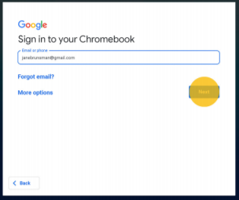 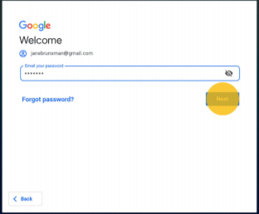

Once you have added your account to the Chromebook, your desktop will look like this the next time you access. Enter the Password then press the enter key or click the right arrow.



Menu expanded.



Check out the [Chromebook Accessibility Guide](https://docs.google.com/document/d/1lXVAjOJAalMGCEju6crw_NVGD-D-bjvTUFZUXihN7uU/edit?usp=sharing) for more information.

Once signed in, your desktop will look similar to the image below.



### 

### App Launcher

The App Launcher gives quick access to commonly used apps and tools, like Files and the Camera.



### Accessing Chrome

Chrome is Google’s Internet browser. Your Organizational Unit (how users are managed by admins, an OU is like a group) determines your launch page. Some users open to their schools website, other to the ClassLink LaunchPad, image below.

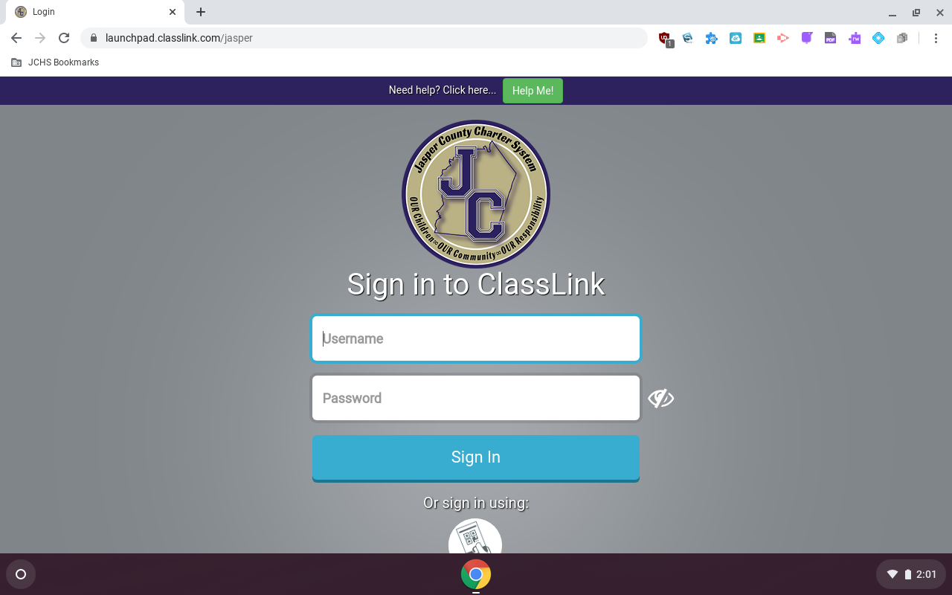

Have issues? Check out these troubleshooting tips.

[Troubleshooting Common Chromebook Issues](https://docs.google.com/document/d/1RsB_reev7JBgl1fuIx-6BJnhkxuwBUplRIn0V366Jtw/edit?usp=sharing)